Know Your Dashboard

When you perform multi order search or execute a report, the system provides you with dashboard providing the order information.

Order information provided in the dashboard view is configurable at microsite, role & user level. User can view the information only when the access is provided.

**Search Summary/Report Summary**

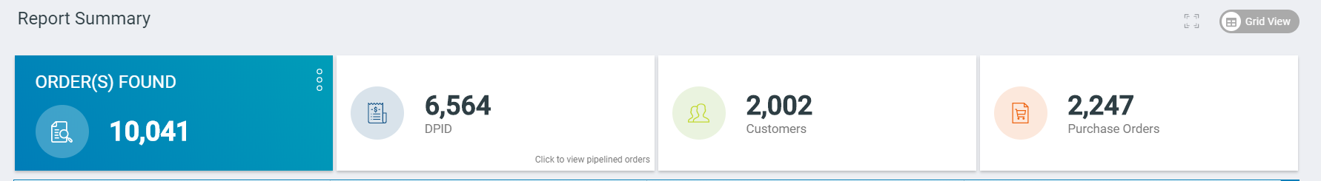

Figure Search/Report Summary

Total Orders found as part of your multi-order search or for the report generated is ‘ORDER(s) FOUND’ (10,041 orders in the above search)

Search summary classifies the total orders found with respect total number of DPIP’s associated with the orders. User can drill the order search summary at a Customer level or Purchase order level.

Note: If the search has resulted in more than 1000 customer or 1000 PO’s, user can’t drill down to customer/PO level.

**Revenue Summary**



Figure Revenue Summary

User can view the max generating revenue for the total orders found. Max 4 revenues are listed in the grid. User can click on the dropdown and view rest of the revenue generating currencies.

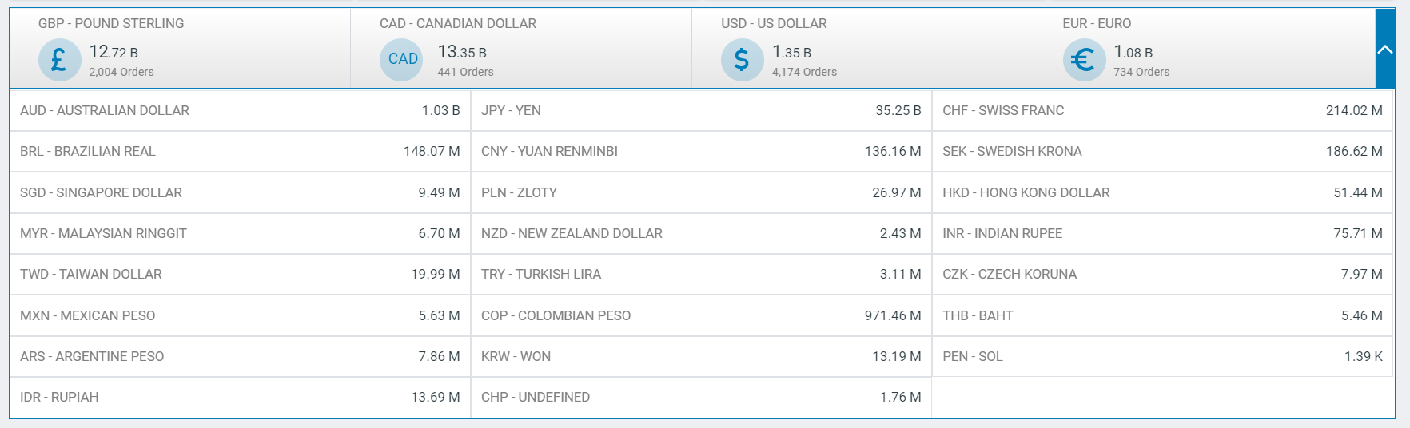

Figure Revenue Summary - All

Note: We’re not doing the currency conversion to generate the revenue summary. System is aggregating the currencies at providing the max currency out of the total orders.

**Predictive Order Health**

You can view the searched orders ‘order health summary’. Orders under ‘Red’ are in Critical Health condition, in ‘Yellow’ are at risk and in ‘Green’ are healthy orders respectively.

Clicking on any of the health section, you will navigate to the grid view with the respective health filter pre-selected and search results shows only those orders that are in the chosen health state.

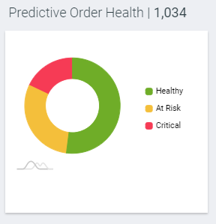

Figure Predictive Order Health

The order health is derived based on the EDD. If the orders can be delivered within the estimated delivery date, then the orders are healthy. If the orders are at risk of missing the estimated delivery date, then the orders are categorized to be ‘At Risk’. Orders that have already missed the delivery date are ‘critical’ orders.

**Customer Communicable Status**

You can view how many orders are in what customer communicable status when you perform multi order search.

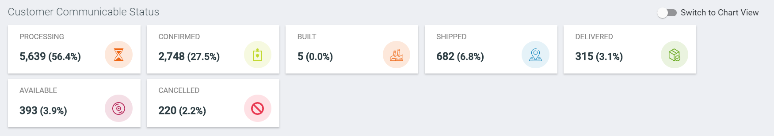

Figure Customer Communicable Status- Tile

System displays the count & percentage of orders in each status;

1. Processing
2. Confirmed
3. Built
4. Shipped
5. Delivered
6. Available
7. Cancelled

By clicking on any of the status, system navigates to the grid view with the respective status filter pre-selected and search results show only chosen status orders.

You can view this tile in the chart format by toggling ‘Switch to Chart View’

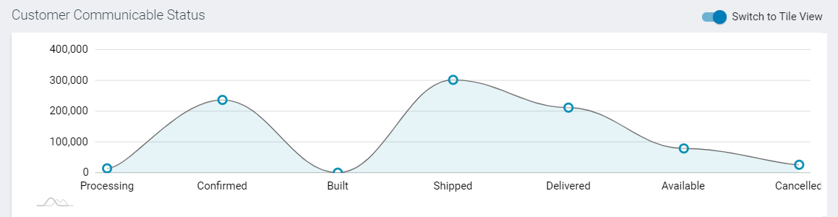

Figure Customer Communicable Status- Chart

**Order on Holds**

When you perform a multi order search, you can view how many orders are on hold and on which hold type. System displays the count & percentage of orders that are different hold from different source;

Order Management Hold

Order Fulfillment Hold

Order logistics Hold

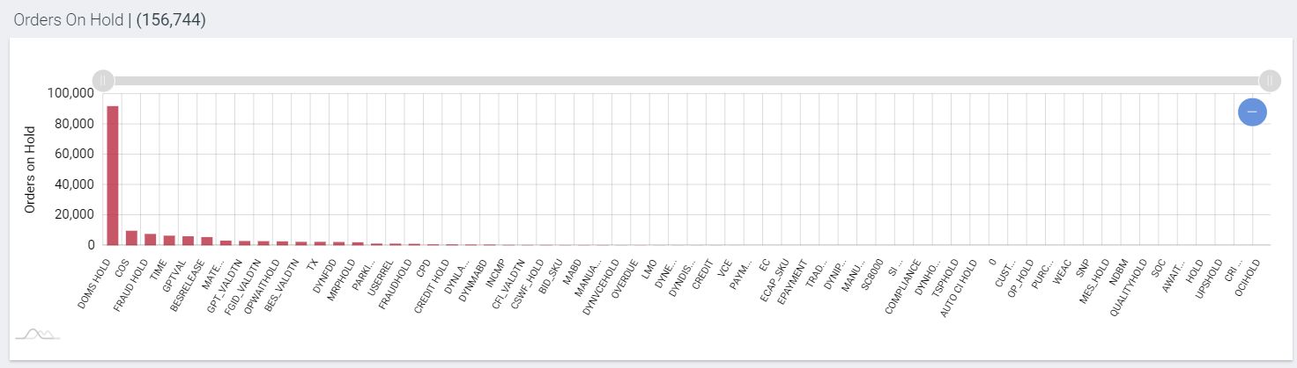

Figure Orders on Hold

On hover over, user can view the order hold, total number of orders count in that hold & percentage (out of total searched orders)

**Hourly Trend**

When you are monitoring a sales dashboard, you would be interested to know what time of the day the maximum orders placed. Hourly trend shows the time of the day when the maximum orders where placed.

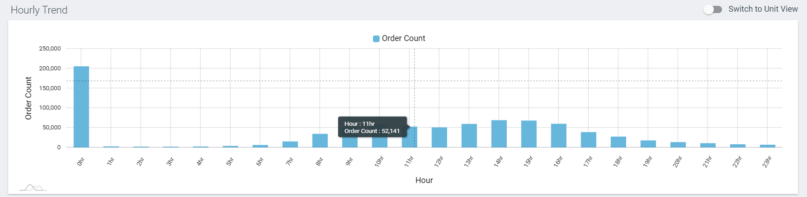

Figure Hourly Trend

You can switch to ‘Unit View’ to know the number of units placed at the specified time of the day.

**Day Trend**

Like ‘Hourly Trend’, Daily trend gives the user the info about the orders placed on each day for the specified day range.

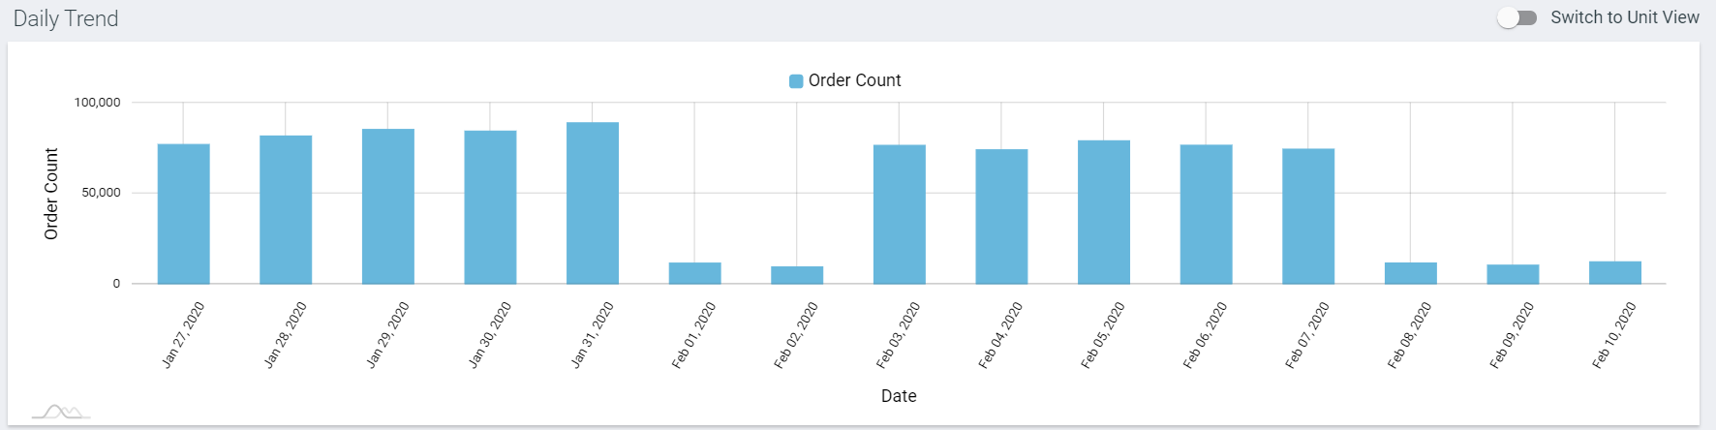

Figure Day Trend

When you perform the multi order search or generate a report on the specified date range, you can view the orders placed on each day within the date range. You can switch to ‘Unit View’ to know the number of units placed on the day.

**Order Experience Trend**

For the specified date range, user can view the overall order experience for all the orders on each day.

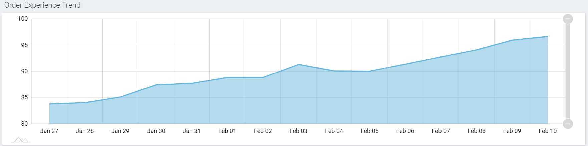

Figure Order Experience Trend

The “OEX Trend" chart will not be displayed if the search/report results contain orders for a single date.

**Order Stage**

when you execute a multi order search or run a report, you can view the count of orders in each of the order stages.

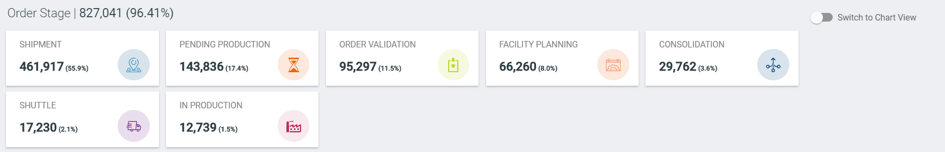

Figure Order Stage -Tiles

You can view the count & percentage of orders that are in each order stages;

* Order Validation
* Pending Production
* Facility Planning
* In Production
* Shuttle
* Consolidation
* Shipment

By clicking on any of the stage, system navigates to the grid view with the respective status filter pre-selected and search results show only chosen order stage.

You can click on the toggle switch and view the order stages in the chart view.

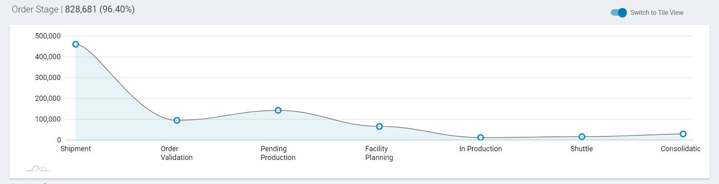

Figure Order Stage - Chart

**Invoice Summary**

You can view the invoice summary for all the searched orders. The information includes-

* Invoiced Orders
* Not Invoiced Orders
* Non-Invoiceable orders

You can view the total count & percentage of orders in each tile to know the number of orders in the status. By clicking on any of the tile, system navigates to the grid view with the respective invoice filter pre-selected and search results show only chosen finance summary.

Cancelled orders are calculated as part of "Not Invoiced" orders.

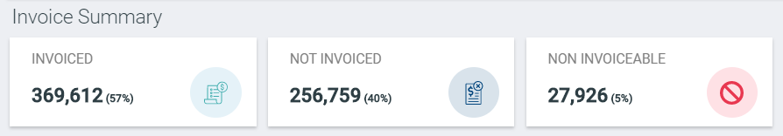

Figure Invoice Summary

**Facilities**

View the facility summary of the searched results, that is; how many orders are in which facility location across the globe. Each dot can proportionately appear to be bigger compared to other based on the percentage of orders in that facility.

On Hover over, you can view the total orders count, facility code, facility name, city & state as a tool tip.

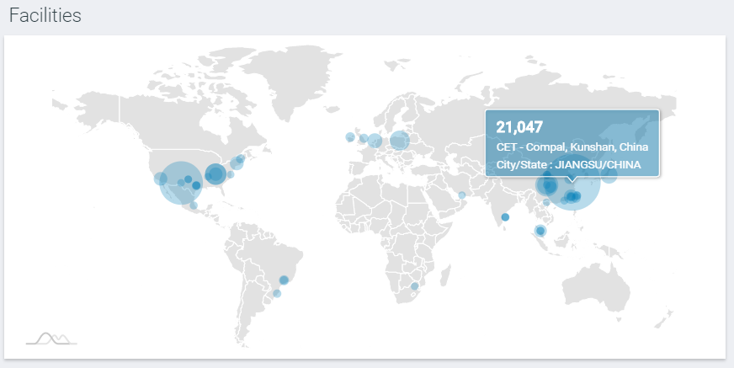

Figure Facilities

By clicking on any of the facility, system navigates to the grid view with the respective facility name filter is pre-selected and search results show only chosen facility code.

**LOB Summary**

You can view LOB’s summary of the executed report or the searched orders. In LOB Summary, view the LOB name and the total orders for that LOB.

On hover over, view the LOB name, total orders with that LOB and the percentage. By clicking on any of the LOB, system navigates to the grid view with the respective LOB filter pre-selected and search results show only chosen LOB.

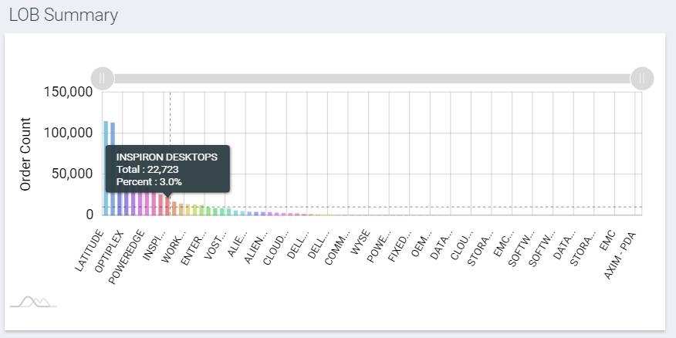

Figure LOB Summary

**Order Experience Summary**

You can view the overall OEX score for the searched orders/executed report, to know the overall experience delivered for the orders. The overall score is the average score of all searched orders.

The tiles shown are of the perfect orders, moderately distressed orders, distressed order and highly distressed orders. Each tile has the order count & percentage with that experience score.

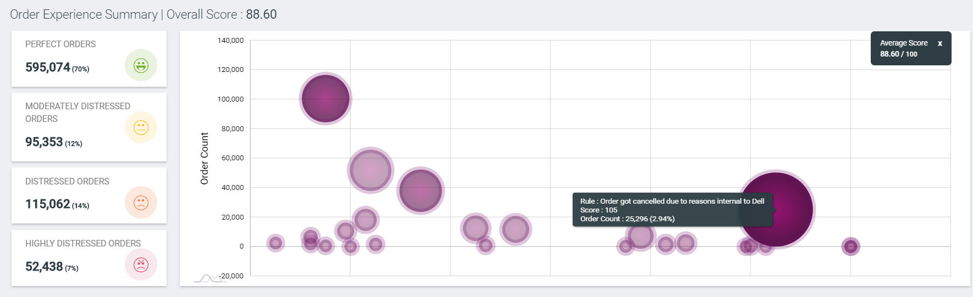

Figure Order Experience Summary

OEX Summary chart shows the actual score w.r.t order count. On hover over at each circle, tool tip shows rule name, OEX score and the total orders count (with that score).

By clicking on any of the OEX tile or OEX score (circle on chart), system navigates to the grid view with the respective OEX range filter pre-selected and search results show only chosen OEX range.

**Delivery Accuracy & Precision (EDD Vs ADD)**

You can view the summary of orders by their EDD accuracy (Early, On-Time, Late) and precision for all the searched orders/executed report.

EDD Summary includes-

* Percentage and number of orders that are Delivered – Ontime
  + EDD max != EDD min and Actual Delivery Date is between EDD min & EDD max end.
  + EDD max = EDD min and trunc(Actual delivery date) = trunc (EDD max)
  + EDD min is not available and trunc(Actual delivery date) = trunc (EDD max)
* Percentage and number of orders that are Delivered – Early
  + If EDD max != EDD min and Actual Delivery Date is before EDDmin.
  + EDD max = EDD min and Actual delivery date is before or equal to EDD max end
  + EDD min is not available and Actual delivery date is before or equal to EDD max end.
* Percentage and number of orders that are Delivered – Late
  + Actual delivery date >  EDD max end.

Delivery Precision is calculated for- 1-2 Days, 3-5 Days, 6-10 Days, 11-19 Days, 20+ Days.

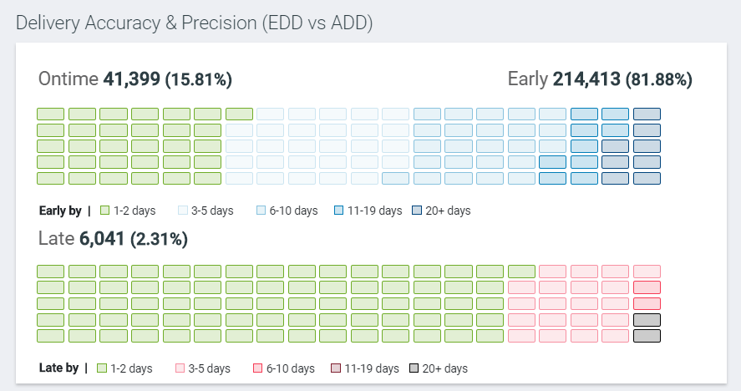

Figure Delivery Accuracy & Precision

By clicking on any of the EDD tile (Ontime, early or late), system navigates to the grid view with the respective EDD range filter pre-selected and search results show only chosen EDD range.

**Shipping Accuracy & Precision (ESD Vs ASD)**

You can view the summary of orders by their ESD accuracy (Early, On-Time, Late) and precision for all the searched orders/executed report.

ESD Summary includes-

* Percentage and number of orders that are shipped – Ontime (Trunc (Actual Ship date) = trunc(ESD))
* Percentage and number of orders that are shipped – Early (Actual Ship Date < ESD)
* Percentage and number of orders that are shipped – Late (Actual Ship Date > ESD)

Shipped Precision is calculated for- 1-2 Days, 3-5 Days, 6-10 Days, 11-19 Days, 20+ Days.

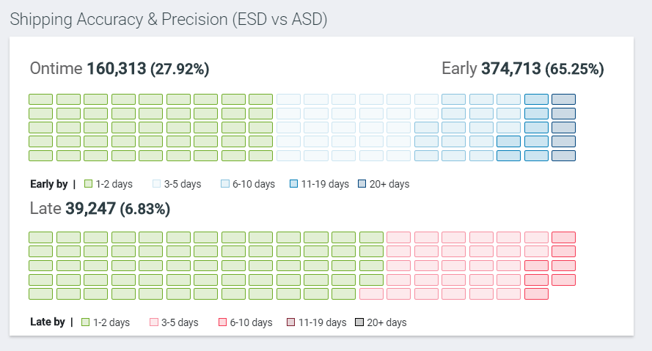

Figure Shipped Accuracy & Precision

By clicking on any of the ESD tile (Ontime, early or late), system navigates to the grid view with the respective ESD range filter pre-selected and search results show only chosen ESD range.

**Delivery Revisions (RDD)**

You can view how many orders have undergone how many delivery revisions for the searched orders/executed report.

For the searched orders, if any of the orders have gone for delivery revisions only then the RDD tiles are listed. The tile shows the order count & percentage with each RDD revision.

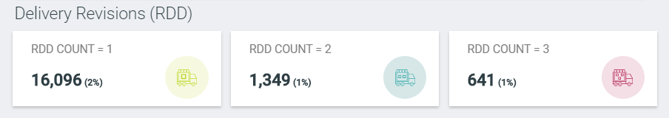

Figure Delivery Revisions (RDD)

By clicking on any of the RDD tile, system navigates to the grid view with the respective RDD count filter pre-selected and search results show only chosen RDD.